**Lab objectives:**

**- Embed SQL statements in two RPGLE programs**

**- Provide related RPGLE code for the embedded SQL statements**

**Requirements to pass the lab:**

**Successfully run the PhoneSQL program after copying supplied code and then adding the embedded SQL code and related RPGLE code that was given out in class.**

**Successfully run the ProvSQL SQL cursor program after copying supplied code and then adding the embedded SQL code and realated RPGLE code that was given out in class.**

PhoneSQL

Input: CUSTOMER19 (accessed by RPGLE read statement)

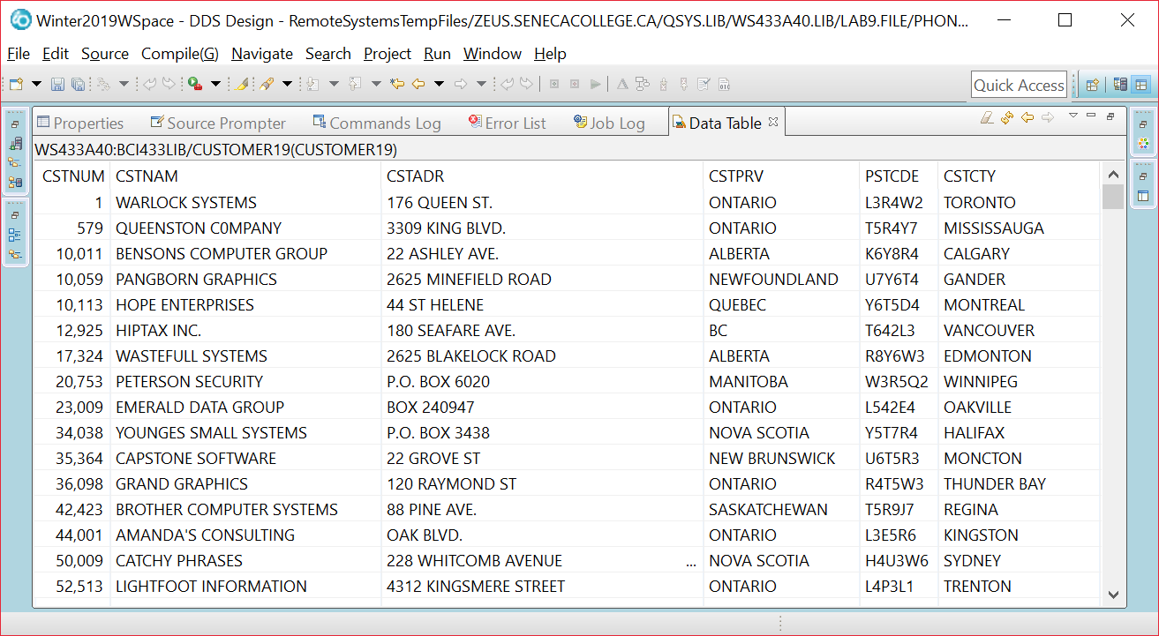CONTACTW19 (accessed through embedded SQL statements)

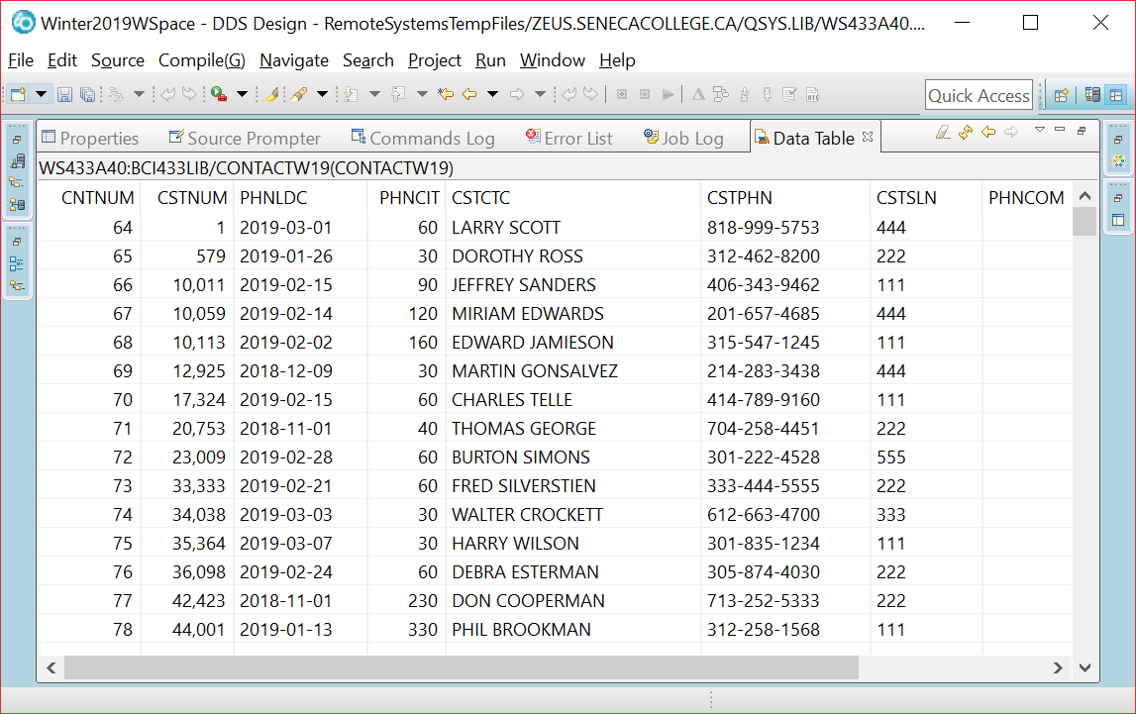

Output:

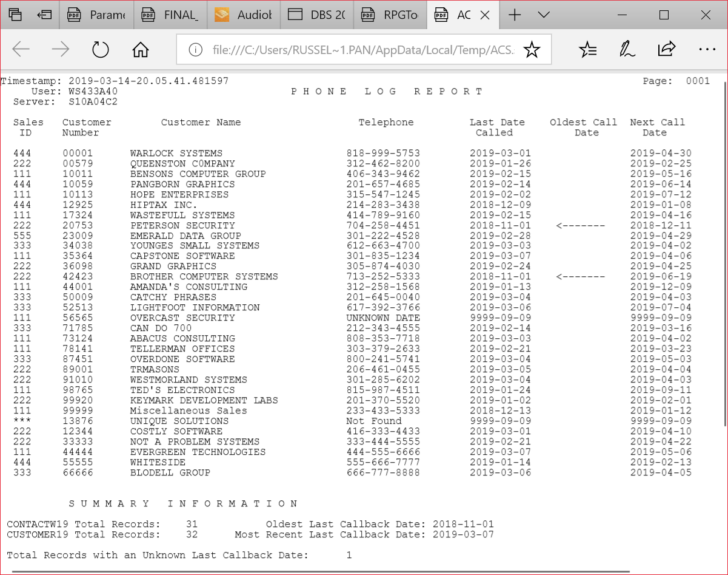

// **************************************************************************

// CUSTOMER19 READ BY NATIVE LANGUAGE (ILE RPG)

// CONTACTW19 ROW RETRIEVED WITH EMBEDDED SQL

// DETAIL REPORT LINE INCLUDES INFORMATION FROM CUSTOMER19 AND CONTACTW19

// SUMMARRY REPORT INFORMATION RETRIEVED WITH EMBEDDED SQL STATEMENTS

// **************************************************************************

DCL-F PHNREPORT PRINTER OFLIND(*IN01) ;

DCL-F CUSTOMER19 DISK(*EXT) KEYED USAGE(*INPUT)

RENAME(CUSTOMER19:CUSTR);

DCL-S Dummy Zoned(1);

// data structure for host variables from CONTACTW19

___________________________________________________________

// Standalone fields for indicator variables

________________________________________________________

________________________________________________________

//**************************************************************************

//* *** M A I N R O U T I N E ***

//**************************************************************************

EXSR SummaryInfo;

EXCEPT HEADINGS;

READ CUSTOMER19;

DOW NOT %EOF;

EXSR SQLSelect;

IF *INOF = *ON;

EXCEPT HEADINGS;

*INOF = *OFF;

ENDIF;

EXCEPT DETAIL;

READ CUSTOMER19;

ENDDO;

EXCEPT TOTALS;

*INLR = *ON;

RETURN;

//*************************************************************************

// S Q L S E L E C T S U B R O U T I N E

//********************************************************************

// A row from the contacts table has the same customer number found in the record

// read from the CUSTOMER19 file. That row is retrieved to find out the last date

// called, phone number, comments and the salesperson number.

// The call back interval is added to the last date called to determine the

// next date to call. Since null values may be stored in the last date called

// indicator variables are used.

//**********************************************************************

// S U M M A R Y I N F O S U B R O U T I N E

//**********************************************************************

BEGSR SummaryInfo;

// D E T E R M I N E T O T A L S F O R CONTACTW19 & CUSTOMER19

// D E T E R M I N E N U M B E R O F U N K N O W N L A S T D A T E

// C A L L E D R E C O R D S

// D E T E R M I N E O L D E S T & M O S T R E C E N T L A S T

// C A L L B A C K D A T E S

// D E T E R M I N E T H E U S E R, S E R V E R, & T I M E S T A M P

PHNREPORT (code available in BCI433LIB/LAB9SQL)

A R HEADINGS

A 2 6'User:'

A 1 1'Timestamp:'

A 3 3'Server:'

A 1105'Page:'

A 1112PAGNBR

A TIMESTAMP Z 1 12

A USER 10 2 12

A SERVER 10 3 12

A 2 48'P H O N E L O G R E P O R T'

A 5 3'Sales'

A 6 4'ID'

A 5 11'Customer'

A 5 27'Customer Name'

A 6 11'Number'

A 6 78'Called'

A 5 59'Telephone'

A 5 77'Last Date'

A 5 90'Oldest Call'

A 6 94'Date'

A 5103'Next Call'

A 6105'Date'

A R DETAIL SPACEB(2)

A CSTSLN R 3REFFLD(CONTACTW19/CSTSLN +

A BCI433LIB/CONTACTW19)

A CSTNUM R 11

A REFFLD(CUSTOMER19/CSTNUM +

A BCI433LIB/CUSTOMER19)

A CSTNAM R 22REFFLD(CUSTOMER19/CSTNAM +

A BCI433LIB/CUSTOMER19)

A CSTPHN R 57REFFLD(CONTACTW19/CSTPHN +

A BCI433LIB/CONTACTW19)

A PHNLDC R 77REFFLD(CONTACTW19/PHNLDC +

A BCI433LIB/CONTACTW19)

A FLAG 8 91

A NEXTCDATE L 103

A R SUMMARY SPACEB(3)

A 12'S U M M A R Y I N F O R M A T I -

A O N'

A 2'CONTACTW19 Total Records:'

A SPACEB(2)

A CONTACTT 5 0 27EDTCDE(1)

A 44'Oldest Last Callback Date:'

A OLDESTDATE L 71

A 2'CUSTOMER19 Total Records:'

A SPACEB(1)

A CUSTOMERT 5 0 27EDTCDE(1)

A 39'Most Recent Last Callback Date:'

A RECENTDATE L 71

A 2'Total Records with an Unknown Last-

A Callback Date:'

A SPACEB(2)

A UNKNOWNT 5 0 52EDTCDE(1)

ProvSQL

INPUT (from three tables)

Manitoba Customers

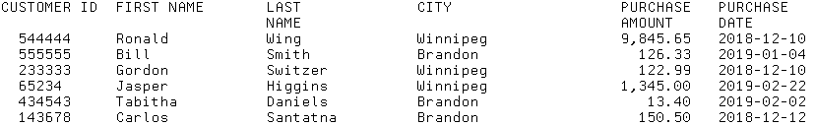

Ontario Customers

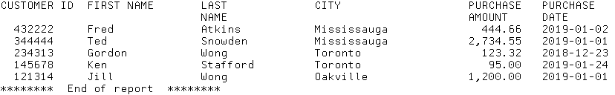

Quebec Customers

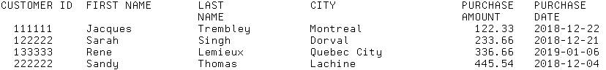

**CALL PROVSQL X'F0F0F4F0F0F0F0'**

OUTPUT:

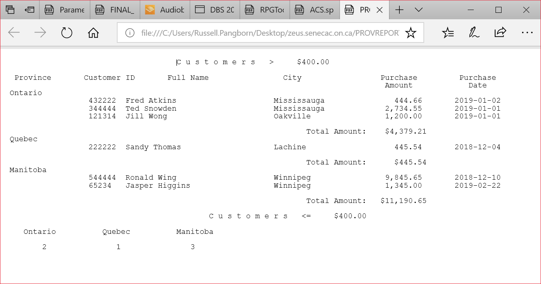

PROGRAM:

//**************************************************************************

//* THIS PROGRAM USES A CURSOR TO LOAD A TEMPORARY RESULT TABLE THAT JOINS T

//* ORDERLINE, CUSTOMER, PART AND SALESREP TABLES. ORDER NUMBER IS USED AS

//* FIELD WHERE CUSTOMER TOTALS ARE PRINTED ON NEW ORDER NUMBERS

//*

//**************************************************************************

DCL-F PROVREPORT PRINTER OFLIND(*IN01) ;

DCL-S ProvinceH Char(10);

DCL-S EndOfFile IND;

DCL-S TotalRecords PACKED(5:0) ;

// LowLimit is passed to the program

// All Host Variables available under a single name

C/EJECT

C* *** M A I N R O U T I N E *** *

/FREE

EXSR PrepareFiles;

Write Title;

Write HEADINGS;

EXSR GetRow;

Write NewProv;

ProvinceH = Province;

DOW NOT EndOfFile;

IF *IN01 = *ON;

Write Title;

Write HEADINGS;

*IN01 = *OFF;

ENDIF;

// Province may change

TotalPurch = TotalPurch + Purchase;

TotalRecords= TotalRecords + 1;

EXSR GetRow;

ENDDO;

Write Totals;

EXSR WRAPUP;

Write UnderLimit;

*INLR = *ON;

RETURN;

// O P E N F I L E S S U B R O U T I N E

BEGSR PrepareFiles;

// S E T U P T H E T E M P O R A R Y R E S U L T S T R U C T U R E

// A T E M P O R A R Y R E S U L T T A B L E I S C R E A T E D

ENDSR;

// G E T R O W S U B R O U T I N E

BEGSR GETROW;

ENDSR;

// W R A P U P S U B R O U T I N E

BEGSR WRAPUP;

ENDSR;

PROVREPORT (code available in BCI433LIB/LAB9SQL)

A R TITLE

A 2 39'C u s t o m e r s >'

A LOWLIMIT 7 2 2 62EDTCDE(1 $)

A R HEADINGS SPACEB(2)

A 4'Province'

A 19'Customer ID'

A 36' Full Name'

A 62'City'

A 83'Purchase'

A 100'Purchase'

A 84'Amount'

A SPACEB(1)

A 102'Date'

A R NEWPROV SPACEB(1)

A PROVINCE 10 3

A R DETAIL

A CUSTID R 20

A REFFLD(ONTARIO/CUSTID BCI433LIB/ONT-

A ARIO)

A SPACEB(1)

A FULLNAME 31 28

A CITY R 60REFFLD(ONTARIO/CITY BCI433LIB/ONTAR-

A IO)

A PURCHASE R 83REFFLD(ONTARIO/PURCHASE BCI433LIB/O-

A NTARIO)

A EDTCDE(1)

A PDATE R 99

A REFFLD(ONTARIO/PDATE BCI433LIB/ONTA-

A RIO)

A R UNDERLIMIT SPACEB(2)

A 46'C u s t o m e r s <='

A LOWLIMIT 7 2 70EDTCDE(1 $)

A 6'Ontario'

A SPACEB(2)

A 23'Quebec'

A 39'Manitoba'

A ONTTOTAL 3 0 8SPACEB(2)

A EDTCDE(1)

A QUETOTAL 3 0 24EDTCDE(1)

A MANTOTAL 3 0 40EDTCDE(1)

A R TOTALS SPACEB(2)

A 67'Total Amount:'

A TOTALPURCH 8 2 82EDTCDE(1 $)